13.AIM: Design PDA using simulator to accept the input string aabb

INPUT:

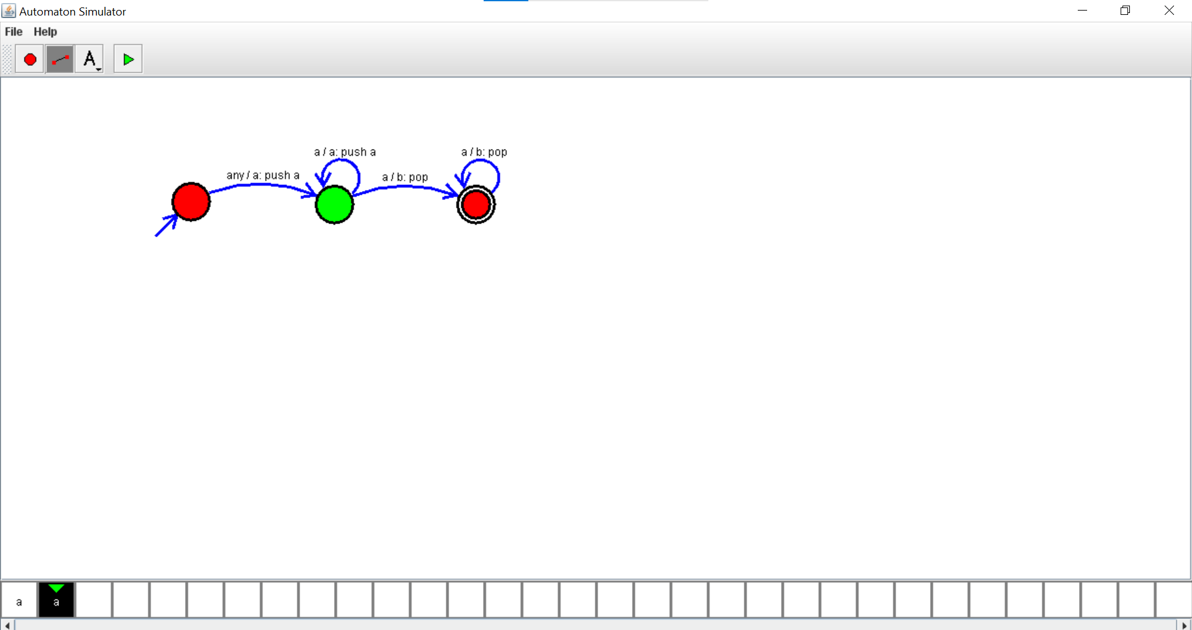

OUTPUT:

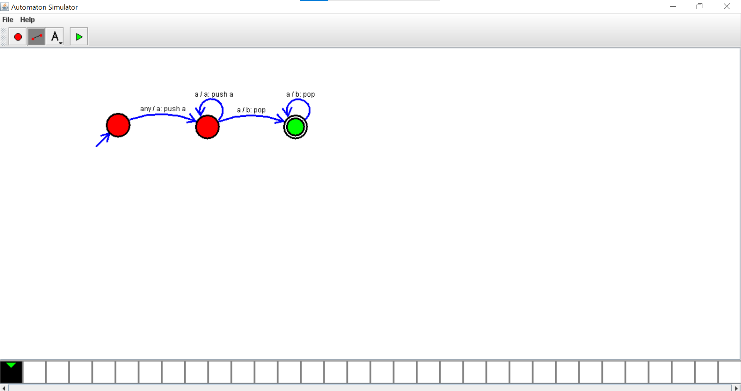

RESULT: thus designed PDA using simulator to accept the input string aabb